A Solution to the Double-Car Freight Train Problem Based on MATLAB

Yuchen Song Student No.201830360498

# Introduction

This project is aimed at solving a double-car freight train problem. In the problem, there are two cars on a slope with an angle of 53.13°. Between the cars, a spring coupling connects them, making them a set of freight train. We are then asked to find the stretch in the spring in two different situations and find the minimum acceleration of the system in the third situation.

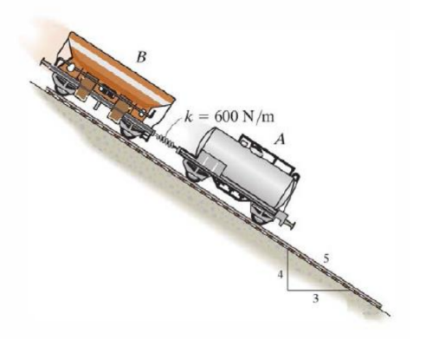

Figure 1 The diagram for the problem

# Solutions

## *Situation I (solution=0m)*

In the very first situation, all the wheels of both cars are free to roll, which means there is no friction. So car A and car B will slip down the slope with the same acceleration. At the same time, they have the same initial velocity(=0), there won’t be any relative displacement between them. As a result, the stretch in the spring will be 0.

## *Situation II (solution=0.955m)*

In this situation, constant brake is applied to car B. The final state can be determined by taking both cars and the spring in between as a whole system. We can calculate the acceleration of the whole system in the end state, then find the force of the spring by applying Newton’s Second Law. Eventually, the stretch in the spring is determined.

$$(m_{A}+m_{B})g\sin{θ}−μm_{B}g\cos{θ}=(m_{A}+m_{B})a ⇒ a=6.21m/s^{2}$$

$$m_{A}g\sin{θ}−F=m_{A}a ⇒ F=573.25N$$

$$F=kx ⇒ x=0.955m$$

## *Situation III (solution=5.7909m/s2)*

The third part is pretty tricky. We are asked to find the minimum acceleration of the system with changeable braking force of B. But no matter how the situation changes, the key point is that when the stretch of the spring reaches maximum, there is no relative movement between car A and car B at that specific moment(i.e, they have the same velocity and the same acceleration). Finally, I listed all the restrictions and solved this linear programming problem with the help of MATLAB.

$$(m_{A}+m_{B})g\sin{θ}−μm_{B}g\cos{θ}=(m_{A}+m_{B})a ⇒ a=\frac{9025.2−4708.8μ}{1150}$$

$$m_{A}g\sin{θ}−F=m_{A}a ⇒ F=\frac{164808μ}{115}$$

$$F=kx ⇒ x=\frac{274.68μ}{115}$$

$$μ≤0.6$$

$$x≤1.2$$

# Codes

Since there is a built-in function to solve the linear programming problems in MATLAB(linprog), I wrote my program in MATLAB. This is a simple program, so I list all my codes here.

|  |
| --- |
| % Author Yuchen Song  % 2021-4-11 17:24  clc;clear;  temp = -4708.8/1150;  c=[temp;0];a=[1,0;0,1]; b=[0.6;1.2];  temp = -274.68/115;  aeq=[temp,1];beq=0;  [x,y]=linprog(c,a,b,aeq,beq,zeros(2,1))  acceleration=y+9025.2/1150 |

In the program, I assumed the braking parameter $μ$ and the stretch in the spring to be the 2 parameters in the linear programming. The restrictions on the linear programming are listed below.(a, b and c are three constants)

$$find min Z=a−bx_{1} ⇒ find min [\begin{matrix}−b & 0\end{matrix}][\begin{matrix}x_{1} \\ x_{2}\end{matrix}] +a$$

$$\left\{\begin{aligned}x_{1}≤0.6 \\ x_{2}≤1.2\end{aligned} ⇒ \right.[\begin{matrix}1 & 0 \\ 0 & 1\end{matrix}][\begin{matrix}x_{1} \\ x_{2}\end{matrix}]≤[\begin{matrix}0.6 \\ 1.2\end{matrix}]$$

$$−cx_{1}+x_{2}=0 ⇒ [\begin{matrix}1 & 0 \\ 0 & 1\end{matrix}][\begin{matrix}x_{1} \\ x_{2}\end{matrix}]=0$$

The result in the console is shown in the following figure.

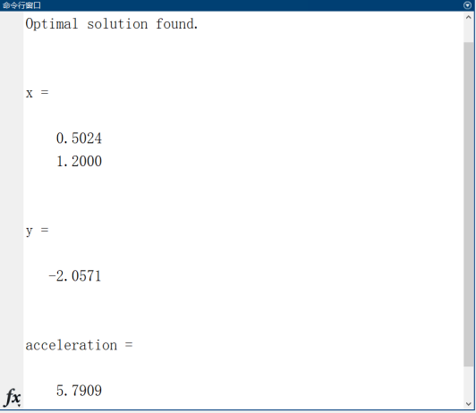

Figure 2 Solutions in the Console

# Discussion

For the enhanced cases with more cars, the key point is the same. That is, no matter how the situation changes, when the stretch of the spring reaches maximum/minimum, there is no relative movement between cars at that specific moment(i.e, they have the same velocity and the same acceleration). So we can get the restrictions from it and use some tools like linear programming to solve the problem.

# Conclusion

In this project, there are three situation settings for the double-car freight train problem, each becomes more difficult(and also more closer to real world). I solved the third problem by using MATLAB and deducted a methodology to solve the similar problem even if there are more cars.